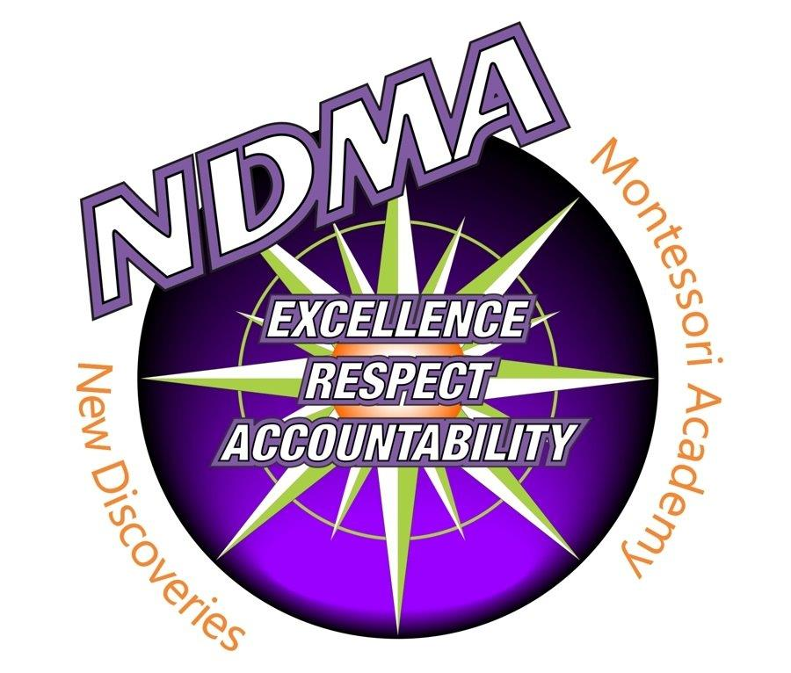

Official Board of Directors
Meeting Minutes

Monday, October 20, 2025 – 5:30 p.m.
NDMA Conference Room

1000 5th Avenue SE, Hutchinson, Minnesota 55350 320.234.6362(w) 320.234.6300(f) www.newdiscoveries.org

The Official Board Meeting of New Discoveries Montessori Academy of Hutchinson, MN
was held at New Discoveries Montessori Academy, Hutchinson, MN.
- Call Meeting to Order – The meeting was called to order at 5:30 p.m.

Voting members present: Tim Dezelske, Patti Hoerner, Jill Montes, Tiffany Knox, Christine La Plante, Spencer Kangas, Shari Colvin (via Teams Meeting).

Voting member absent: Bruce Rhoda

Non-voting member present: Kirsten Kinzler, Director.
Tara Erickson, Recorder
- Guests: Cyndi Lauer, NDMA Music Specialist and Rachel Randall, NDMA Library Specialist.

- Spotlight Report – Specialist Presentations by Mrs. Lauer, Ms. Randall, and Mr. Kangas (Physical Education/Health/DAPE) shared how they run their programs at NDMA. Mrs. Lauer shared how she teaches music lessons to the different grade levels and how well it aligns with Montessori. She shared how grateful she is for the wonderful materials and instruments she has in her classroom. She talked about her music programs noting that this year the theme is “The Four Seasons of Music”. Ms. Randall shared a snapshot of NDMA’s Library growth over the years from thousands of books donated to moving to AASL framework for school libraries… she also repairs books. Randall sees 3 main areas of Library learning: 1. Reading for fun, 2. Manners/Information system, 3. Life Learning. She has a passion for media literacy. She provides read-a-louds, discussion questions, library skills, interactive activities, and lots of book displays to keep the students interested. Mr. Kangas shared the MN Phyed standards that he displays for the students in the MPR. E3 skills are life-long skills. They have even been out playing on the frisbee golf courses in Hutchinson. A highlight for this class is the “Winter Classic” hockey game, he is hoping to have a live google feed set up this year for parents to watch from home. The specialists look forward to working with the students.

- Agenda – MS (Dezelske/Montes) to approve the agenda, all aye; motion carries unanimously.
- MS (Dezelske/Montes) to approve the consent agenda, all aye; motion carries unanimously.
  - Minutes of September 22, 2025 Meeting
  - Submitted Committee Reports
    - Financial Committee met on October 15, 2025 – Kinzler shared that they are considering changing the ADM in the budget, the wolf ridge trip is showing as a large expense due to transportation costs having a 50% increase.
- Financial Reports
  - Received the September 2025 financial
  - MS (Dezelske/La Plante) to approve September 2025 supplemental information report, nothing stood out, all aye; motion carries unanimously by roll call.

- Reports
  - Executive Director – see attached director’s report.
    - Personnel changes: none at this time.
    - Strategic Plan Update:
    - Environmental Education Update: Community Day with the city of Hutchinson workers.
    - Academic Testing and Achievement Update: NWEA and Fall Benchmark Assessments have been completed. Next month a new assessment called Capti-Basix will be started.
    - Enrollment Update: K-8 177, PK8 203
    - Activities and Happenings related to the school, staff, students, families, community: the current fundraiser is Puffins to help cover the cost of field trips.
  - Board Activities
    - Board training was done by Director Kinzler at 5 p.m. MSBA Charter Policies, Open Meeting Law, and Charter School Provisions (MN Statute 124E). Attendees: Kinzler, Hoerner, Kangas, Dezelske, Montes, LaPlante, Knox, Erickson.
- Unfinished Business

- New Business
  - MS (Dezelske/Hoerner) to Review and Approve all policies under 9.a. – most just have date changes and a few formatting updates – motion carries unanimously.
    - 214P – Out of State Travel by Board Members
    - 404P – Employment Background Check
    - 406.1P - Data Practices
    - 406P – Public and Private Personnel Data
    - 412P – Expense Reimbursement
    - 413P – Harassment & Violence
    - 414P – Mandated Reporting of Child Neglect or Abuse
    - 415P – Mandated Reporting of Maltreatment of Vulnerable Adults
    - 506P – Student Discipline and Dismissal
    - 514P – Student Bullying Prohibition
    - 522P – Student Sex Nondiscrimination
    - 524P – Technology Resources Use
    - 533P – Wellness
    - 536P – Student Fees
    - 616P – School District System Accountability
    - 705P – Electronic Fund Transfer

- Upcoming Meetings/Events/Announcements
  - Special board meeting on Friday, October 31, 2025 – 9:00 a.m.
  - Next board meeting, November 17, 2025 – 5:30 p.m.
  - Finance Committee Meeting, November 10, 2025 – 11:45 a.m.
  - Policy/Governance Committee Meeting, November 10, 2025 12:15 p.m.

- Adjournment 06:35 p.m.

Respectfully submitted,
Tara Erickson

Recorder

